CS442 — Mobile Application Development
Lab 3: Campus Cafe Order System
Name: Rafia Naeem
Roll No: 04072313032
Lab: Session 3 — Part 1
Language: Dart

Checkpoint 1 — Classes and Objects
Seed: 32 (t=3, u=2)
Concept Covered: Classes and Objects
Code Implemented: Dish class and creation of Dish objects.
Output:
Step 1: Mocha Rs 123
Step 1: Samosa Rs 128
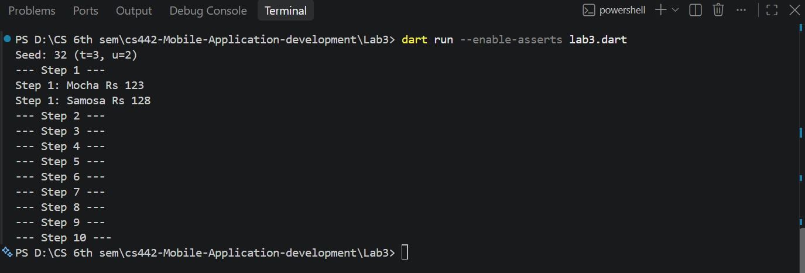
Figure 1Checkpoint 1 output showing the implementation of classes and objects.
Checkpoint 2 — Constructors and this
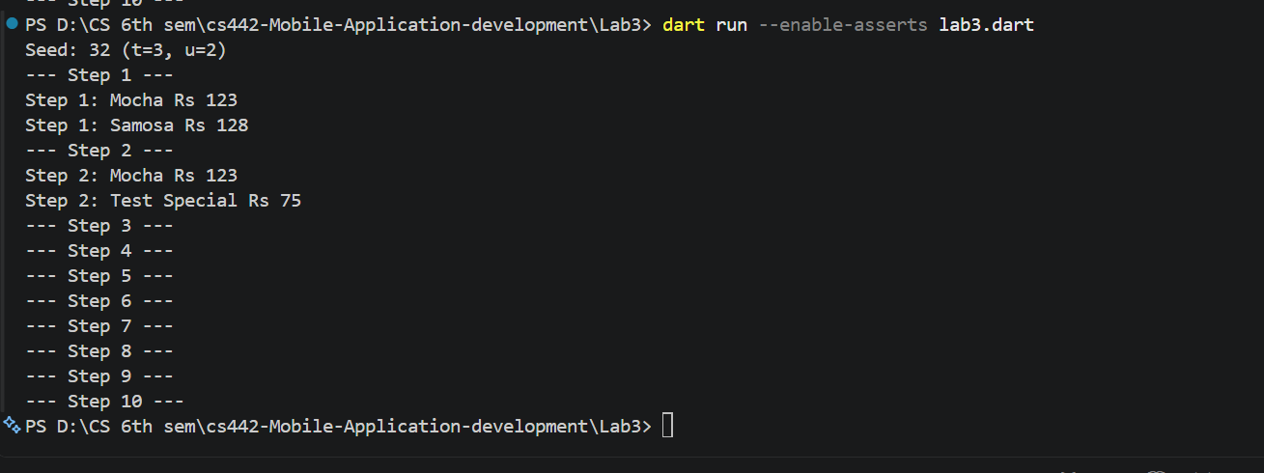

Checkpoint 3 — Named Constructors
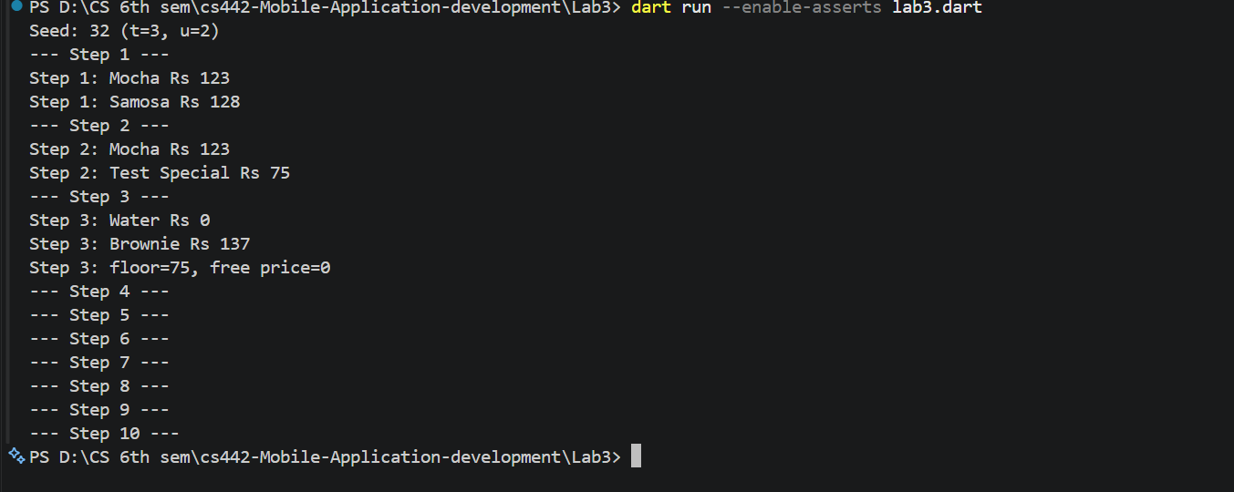

Checkpoint 4 — Factory Constructor
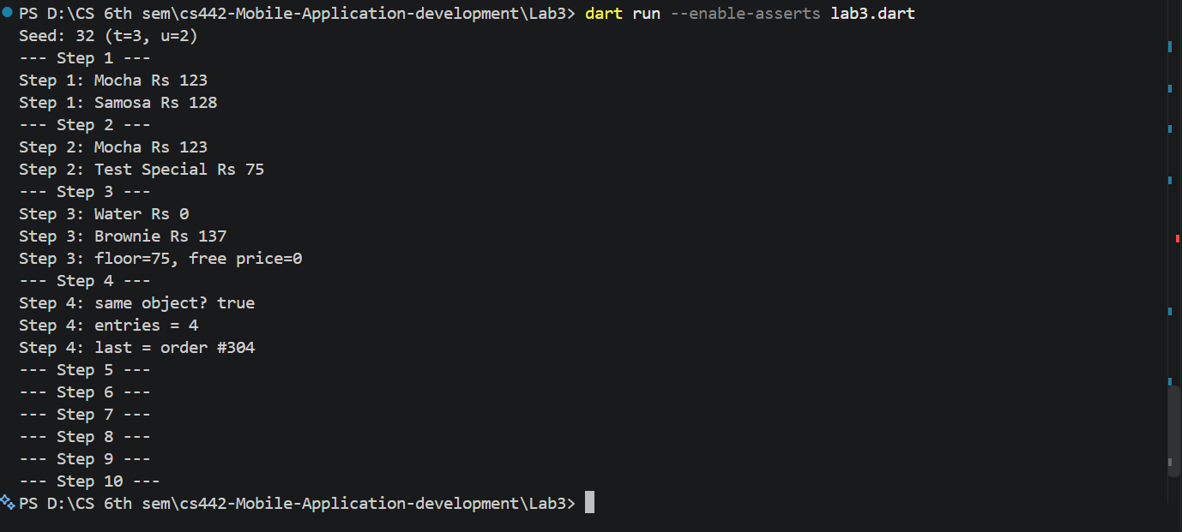

Checkpoint 5 — Initializer Lists and Assertions

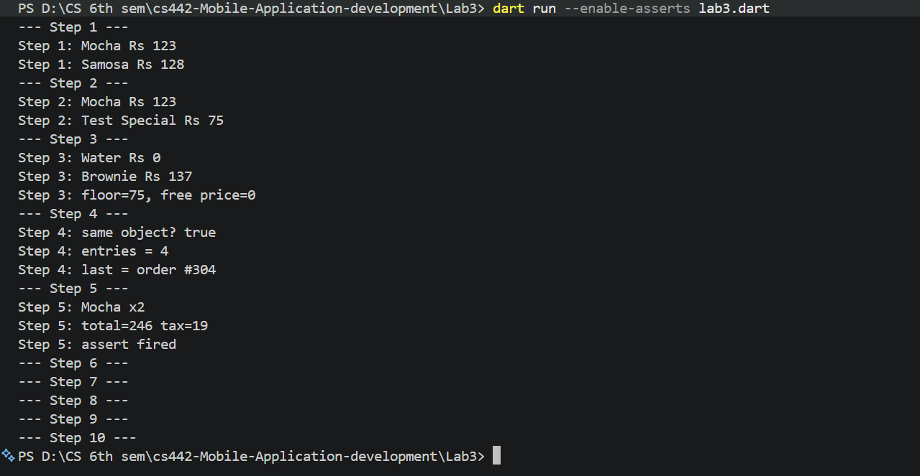

Checkpoint 6 — Getters
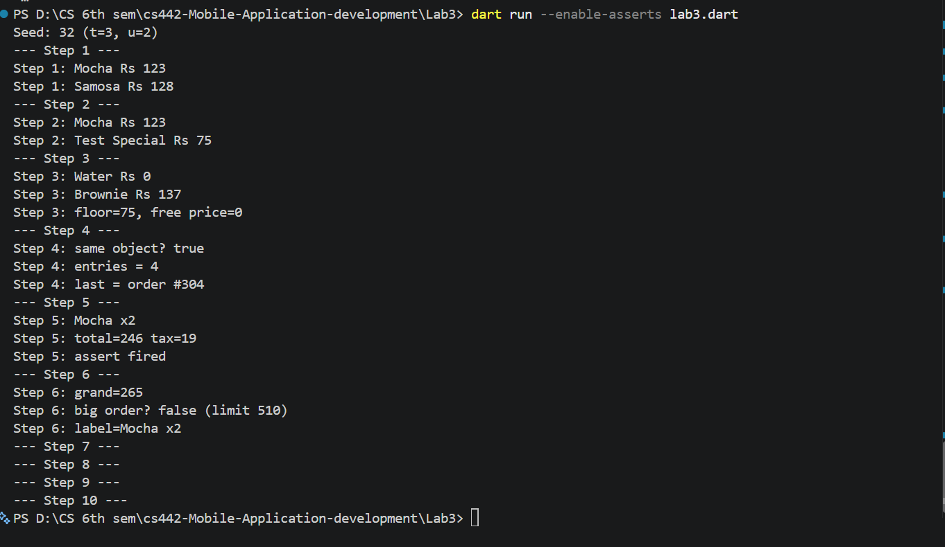
Checkpoint 7 — Getters and Setters

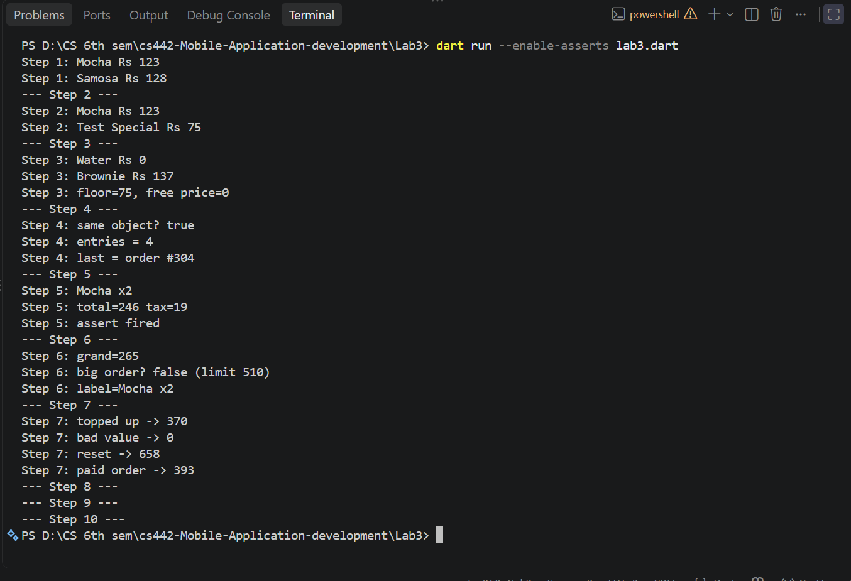

Checkpoint 8 — Menu, toString(), and Collections

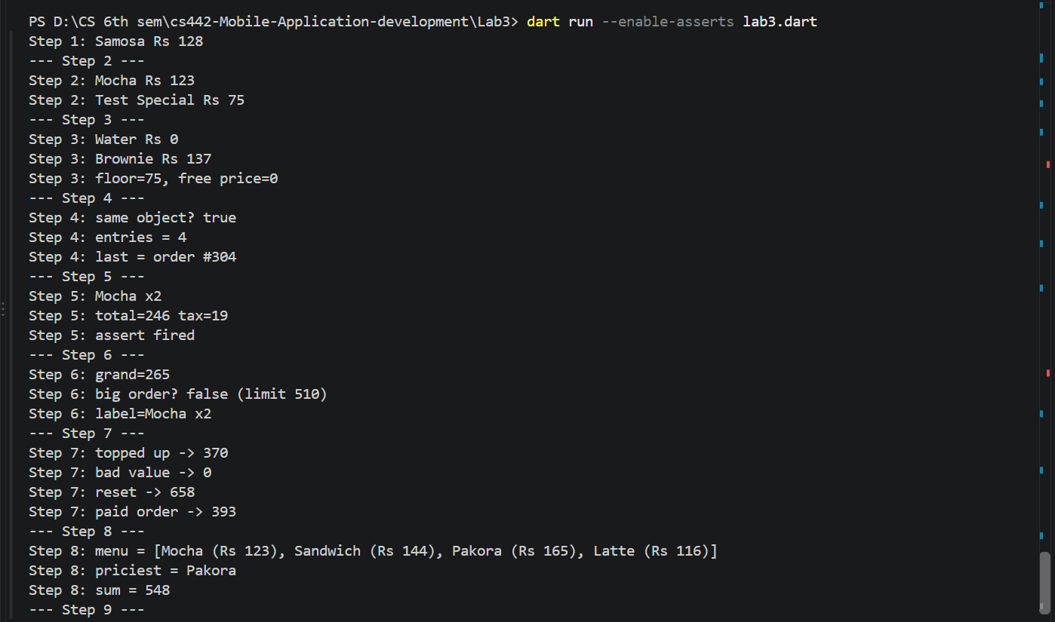

Checkpoint 9 — Receipt and Order Log
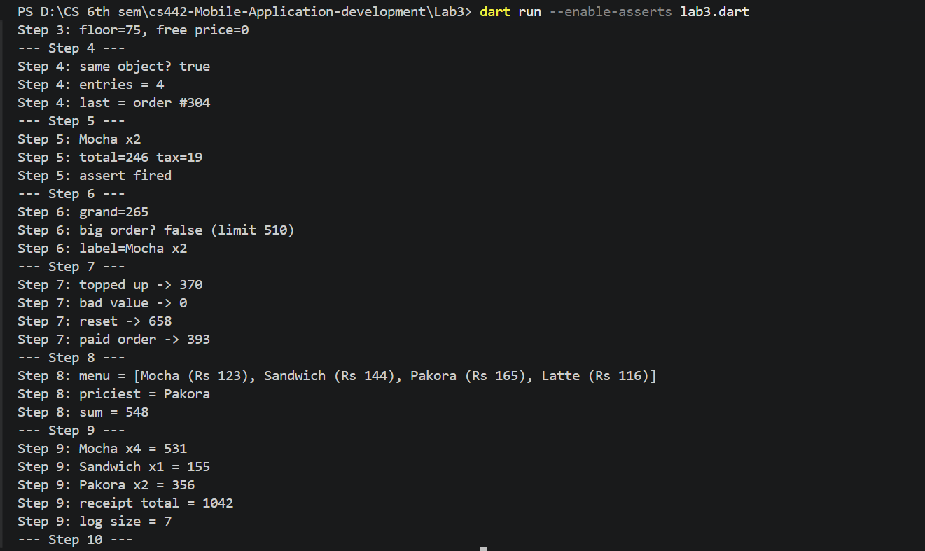

Checkpoint 10 — Coupon Capstone
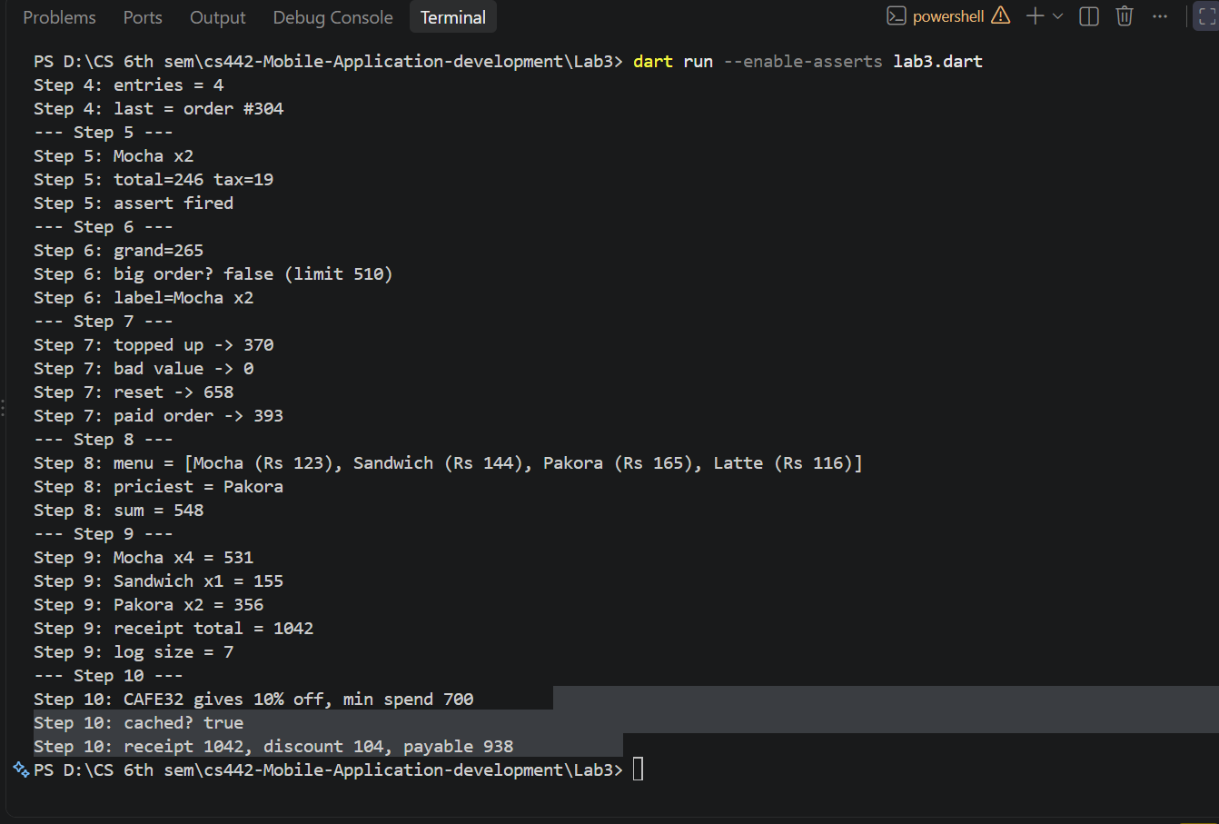

Wrap-up Reflection Questions
Q1. Animal(this.name, this.type); and the verbose constructor give the same result. What does the shorthand save you?
The shorthand constructor saves us from writing the parameters separately and then assigning each parameter to its corresponding field manually. For example, instead of writing Animal(String name, String type) and then using this.name = name and this.type = type inside the constructor body, we can simply write Animal(this.name, this.type);. It reduces the amount of code we have to write and makes the constructor easier to read while giving the same result.
Q2. When would you choose a named constructor, and when a factory constructor?
I would choose a named constructor when I want to provide different ways of creating an object from the same class. For example, in our MenuItem class, MenuItem.free() and MenuItem.fromString() allow us to create a menu item in different ways. I would choose a factory constructor when I need more control over the object that is returned, such as checking a cache and returning an existing object instead of creating a new one. In our Coupon class, the factory constructor returns the cached coupon when the same code is requested again.
Q3. What is the difference between assigning a field in a constructor body and assigning it in an initializer list?
When a field is assigned in the constructor body, the assignment happens after the fields have already been initialized. An initializer list runs before the constructor body, so it is useful when a field needs to be initialized as the object is being created, especially when the field is final. For example, in our OrderLine class, we used the initializer list to calculate total and tax when the object is created.
Q4. Give one reason to use a getter instead of storing the value in a field, and one reason to use a setter instead of a public field.
A getter is useful when a value can be calculated from other fields, because we do not need to store an extra copy of that value. In our OrderLine class, the grand getter calculates the total and tax whenever it is needed. A setter is useful when we want to control or validate a value before changing it. For example, our StudentCard setter makes sure that the balance cannot become negative or go above the allowed balance limit.

